# Module :6

• What are the advantages of Bootstrap?

Ans:- Easy initiation. Coding is a hurricane task for a person who is unbeknownst to web development. ...

Responsiveness. ...

Highly customizable. ...

Extremely user-centric. ...

Top-notch support. ...

Cross-browser compatibility. ...

JavaScript plugins to your rescue. ...

Far-reaching popularity.

• What is a Bootstrap Container, and how does it work?

Ans:- Containers are the most basic layout element in Bootstrap and are required when using our default grid system. Containers are used to contain, pad, and (sometimes) center the content within them. While containers can be nested, most layouts do not require a nested container.

Our default .container class is a responsive, fixed-width container, meaning its max-width changes at each breakpoint.

<div class="container">

<!-- Content here -->

</div>

Responsive containers allow you to specify a class that is 100% wide until the specified breakpoint is reached, after which we apply max-widths for each of the higher breakpoints. For example, .container-sm is 100% wide to start until the sm breakpoint is reached, where it will scale up with md, lg, xl, and xxl.

<div class="container-sm">100% wide until small breakpoint</div>

<div class="container-md">100% wide until medium breakpoint</div>

<div class="container-lg">100% wide until large breakpoint</div>

<div class="container-xl">100% wide until extra large breakpoint</div>

<div class="container-xxl">100% wide until extra extra large breakpoint</div>

Use .container-fluid for a full width container, spanning the entire width of the viewport.

<div class="container-fluid">

...

</div>

• What are the default Bootstrap text settings?

Ans:- Bootstrap 5 uses a default font-size of 1rem (16px by default), and its line-height is 1.5. In addition, all <p> elements have margin-top: 0 and margin-bottom: 1rem (16px by default).

• What do you know about the Bootstrap Grid System?

Ans:- Bootstrap's grid system uses a series of containers, rows, and columns to layout and align content. It's built with flexbox and is fully responsive. Below is an example and an in-depth look at how the grid comes together.

Bootstrap's grid system allows up to 12 columns across the page.

If you do not want to use all 12 column individually, you can group the columns together to create wider columns:

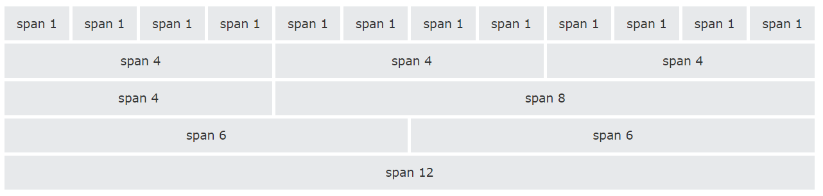

Grid Classes

The Bootstrap grid system has four classes:

xs (for phones - screens less than 768px wide)

sm (for tablets - screens equal to or greater than 768px wide)

md (for small laptops - screens equal to or greater than 992px wide)

lg (for laptops and desktops - screens equal to or greater than 1200px wide)

The classes above can be combined to create more dynamic and flexible layouts.

Tip: Each class scales up, so if you wish to set the same widths for xs and sm, you only need to specify xs.

Grid System Rules

Some Bootstrap grid system rules:

Rows must be placed within a .container (fixed-width) or .container-fluid (full-width) for proper alignment and padding

Use rows to create horizontal groups of columns

Content should be placed within columns, and only columns may be immediate children of rows

Predefined classes like .row and .col-sm-4 are available for quickly making grid layouts

Columns create gutters (gaps between column content) via padding. That padding is offset in rows for the first and last column via negative margin on .rows

Grid columns are created by specifying the number of 12 available columns you wish to span. For example, three equal columns would use three .col-sm-4

Column widths are in percentage, so they are always fluid and sized relative to their parent element

• What is the difference between Bootstrap 4 and Bootstrap 5

Ans:- 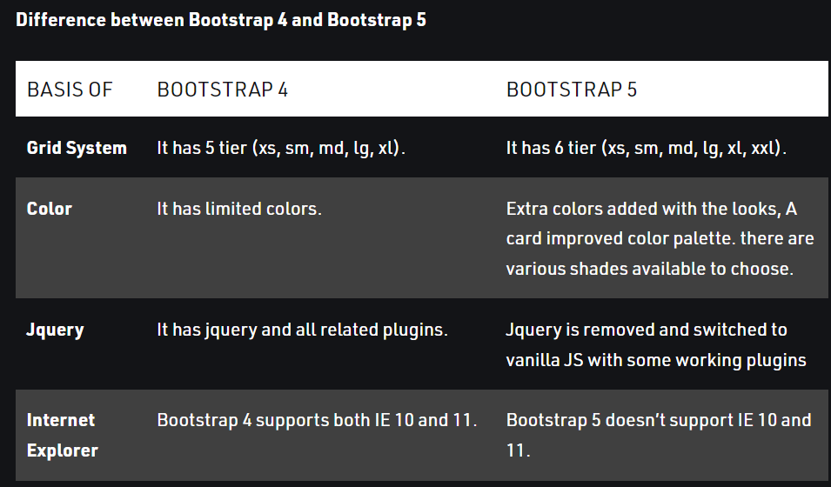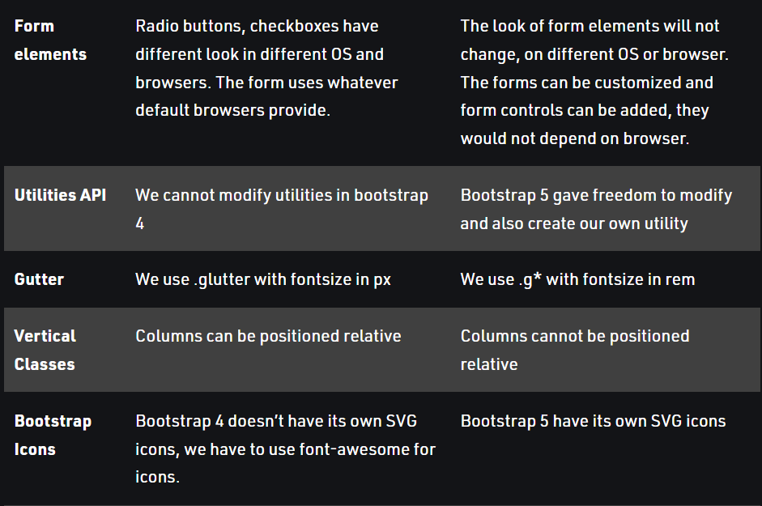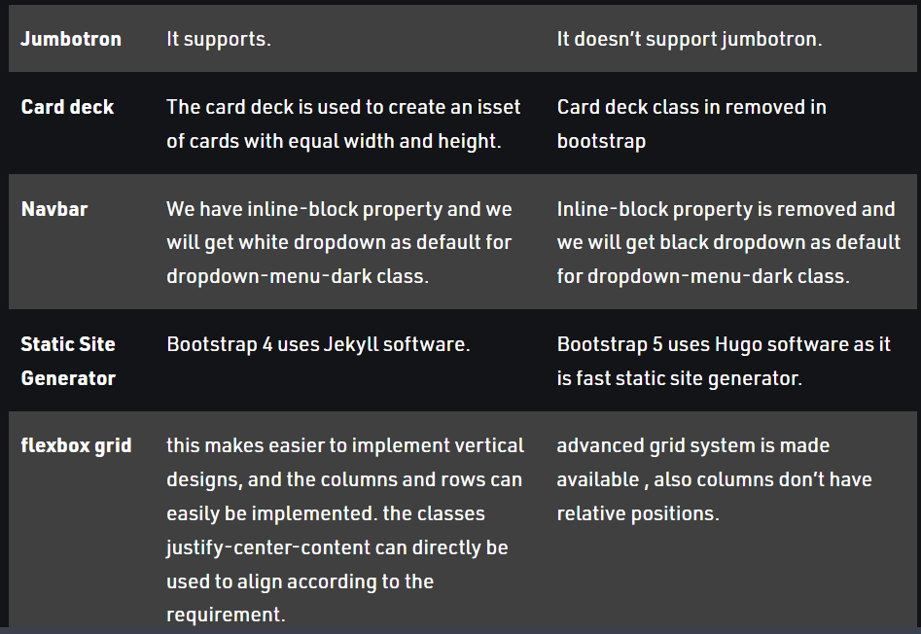

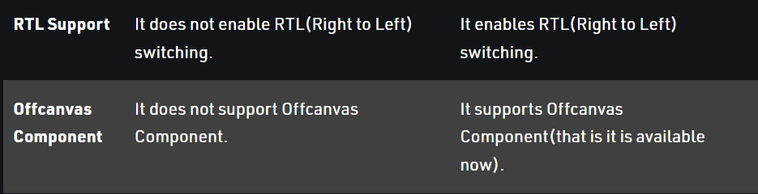

• What is a Button Group, and what is the class for a basic Button Group?

Ans:- “Button Groups” in Bootstrap is a class of name “btn-group” which is used to create series of buttons in groups (without spaces) vertically or horizontally.

This is the basic syntax of the button group class where each button has its own class of “btn”.

Adding Styles on Buttons: Bootstrap allows you to add styles to your buttons using the following classes:

.btn-default

.btn-primary

.btn-success

.btn-info

.btn-warning

.btn-danger

.btn-link

• How can you use Bootstrap to make thumbnails?

Ans:- <!DOCTYPE html>

<html lang="en">

<head>

<title>Bootstrap Example</title>

<meta charset="utf-8">

<meta name="viewport" content="width=device-width, initial-scale=1">

<link rel="stylesheet" href="https://maxcdn.bootstrapcdn.com/bootstrap/3.4.1/css/bootstrap.min.css">

<script src="https://ajax.googleapis.com/ajax/libs/jquery/3.6.1/jquery.min.js"></script>

<script src="https://maxcdn.bootstrapcdn.com/bootstrap/3.4.1/js/bootstrap.min.js"></script>

</head>

<body>

<div class="container">

<h2>Thumbnail</h2>

<p>The .img-thumbnail class creates a thumbnail of the image:</p>

<img src="cinqueterre.jpg" class="img-thumbnail" alt="Cinque Terre" width="304" height="236">

</div>

</body>

</html>

• In Bootstrap 4, what is flexbox?

Ans:- The biggest difference between Bootstrap 3 and Bootstrap 4 is that Bootstrap 4 now uses flexbox, instead of floats, to handle the layout.

The Flexible Box Layout Module, makes it easier to design flexible responsive layout structure without using float or positioning. If you are new to flex, you can read about it in our CSS Flexbox Tutorial.

Note: Flexbox is not supported in IE9 and earlier versions.

If you require IE8-9 support, use Bootstrap 3. It is the most stable version of Bootstrap, and it is still supported by the team for critical bugfixes and documentation changes. However, no new features will be added to it.

To create a flexbox container and to transform direct children into flex items, use the d-flex class:

• How can one create an alert in Bootstrap?

Ans :- <div class="alert alert-success">

<strong>Success!</strong> Indicates a successful or positive action.

</div>

• What is a bootstrap card and how would you create one?

Ans :- A card is a flexible and extensible content container. It includes options for headers and footers, a wide variety of content, contextual background colors, and powerful display options. If you’re familiar with Bootstrap 3, cards replace our old panels, wells, and thumbnails. Similar functionality to those components is available as modifier classes for cards.

<div class="card" style="width: 18rem;">

<img src="..." class="card-img-top" alt="...">

<div class="card-body">

<h5 class="card-title">Card title</h5>

<p class="card-text">Some quick example text to build on the card title and make up the bulk of the card's content.</p>

<a href="#" class="btn btn-primary">Go somewhere</a>

</div>

</div>